EcomPlugins Extension Installation Guide

UPS SurePost Shipping Carrier

Shipping by Zip Code Extension for Magento® 2.x

**Description:**

**Please Note: This extension was not created by the UPS Carriers company. EcomPlugins have built this extension to facilitate a quick Address API integration with UPS Carriers.**

This [**UPS**](https://www.ups.com/in/en/Home.page) module enables you to get ups sure post API rates where package weight is 1 to 9 lbs. It will be mainly use for small items shipping with minimum cost to customer.  You should check all screenshots to understanding the flow of extension.

This [**UPS**](https://www.ups.com/in/en/Home.page) module will send a package weight, customer address and shipper address to get exact rates. There will be admin setting to get discounted rates. Seller can enable / disable it also. Admin can define min and max weight to allow to get ups sure post shipping rates on checkout / cart page.

Admin can disable plugin for frontend checkout too.

## Account & Pricing:

You need to sign up for a [**free** UPS **services account**](https://www.ups.com/in/en/Home.page)to use that module. You have to enter username and password to make it work. You can get all these api details from UPS. You need to sign up and create account on usps.com.

**Admin Features:**

* You can enable / disable module.
* You can enter min and max weight.
* You can change setting to get discounted rates or not.
* You can disable plugin for frontend users and just enable admin checkout only.

**Configurations:**

To use this module, Seller must have UPS API keys account details. These keys you have to update in shipping module setting in admin panel.

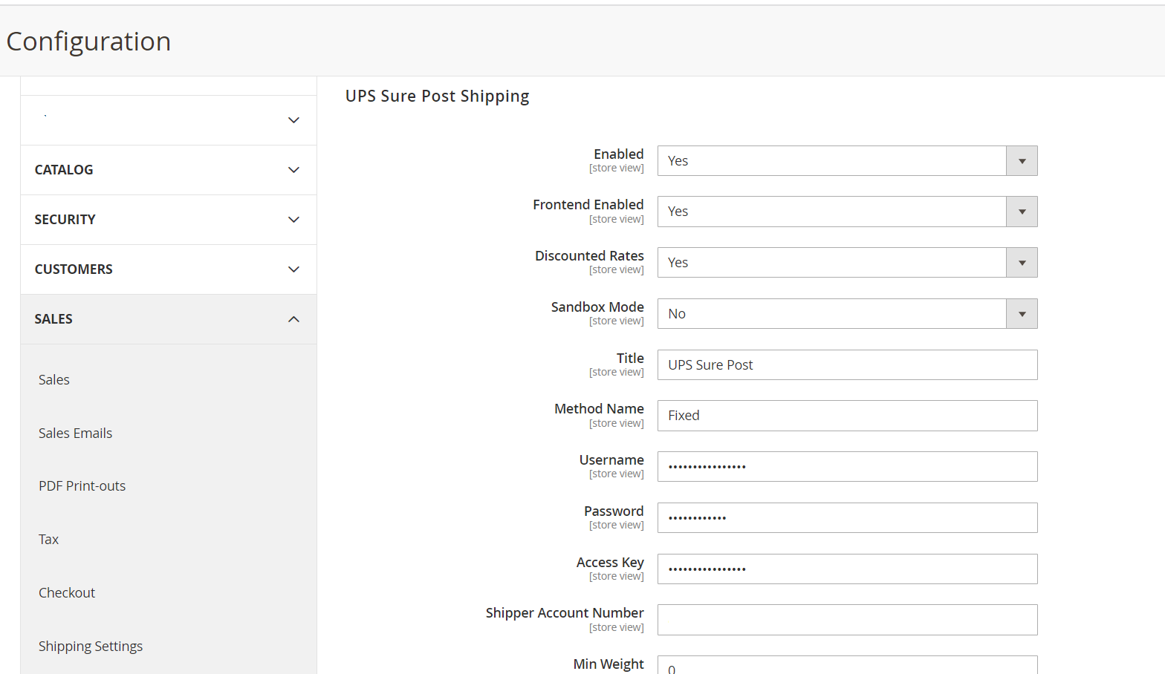

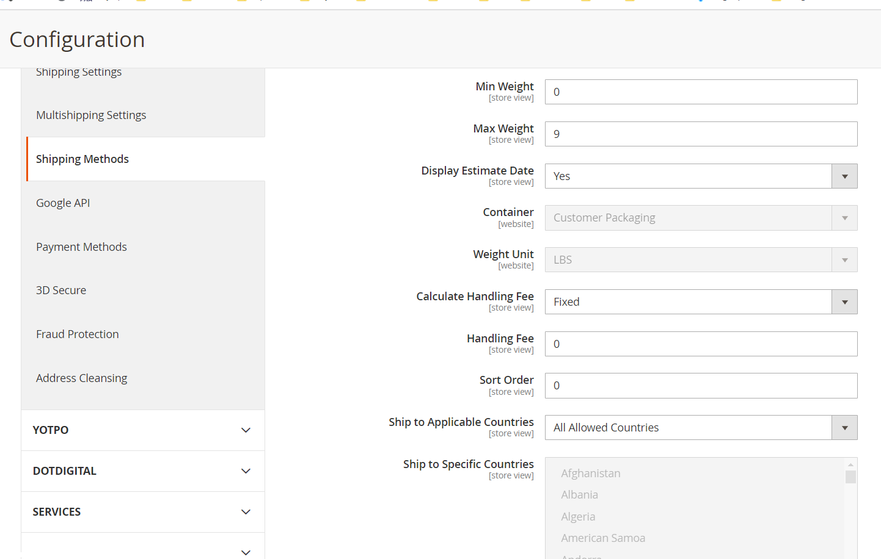

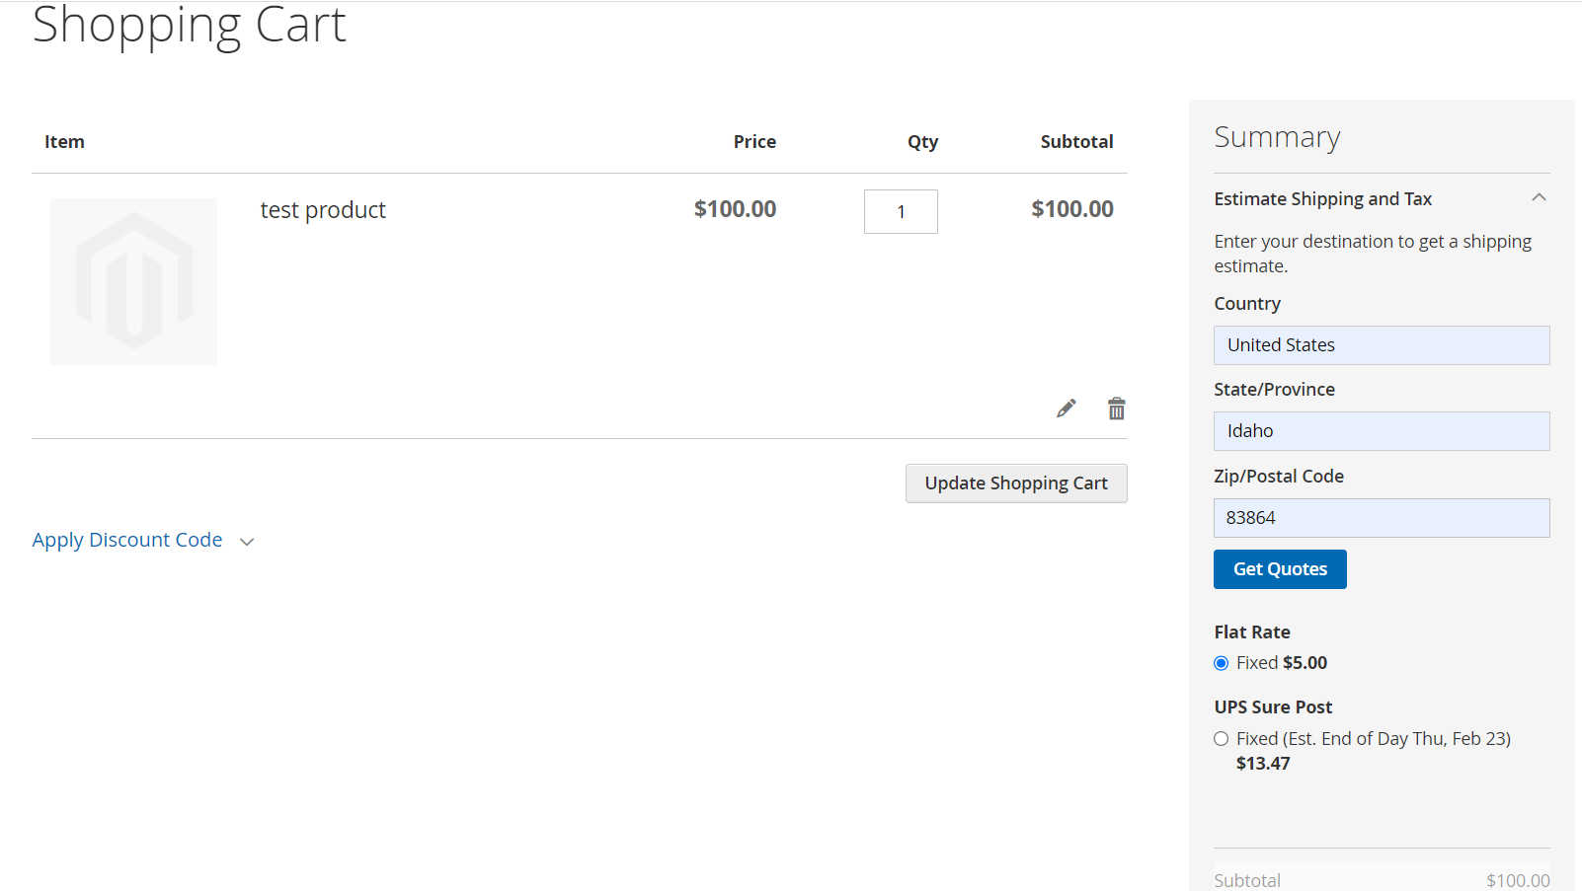

* Go to Stores -> Configuration -> Sales -> Delivery Methods -> UPS SurePost Settings.
* Enter API KEYS details.
* Now Relax, all done.